CO3 ASSESSMENT TOOL 2– Case Study

Question 1 – Harris Corner Detection for Satellite Image Registration
Introduction
Satellite images of the same geographical region may be captured at different times. Due to changes in illumination, image orientation, viewing angle, scale, and background details, the images may not be perfectly aligned.
The system initially uses edge detection to identify matching regions. However, edges are often not distinctive enough for accurate matching. Therefore, Harris Corner Detection can be used to identify stable and distinctive feature points and improve image registration.
Limitations of Edge Detection
Edge detection identifies pixels where there is a sudden change in image intensity.
Major limitations:
- Detects edges and boundaries, rather than distinctive points.
- Rotation and viewing-angle changes can affect matching.
- Noise may produce unwanted edges.
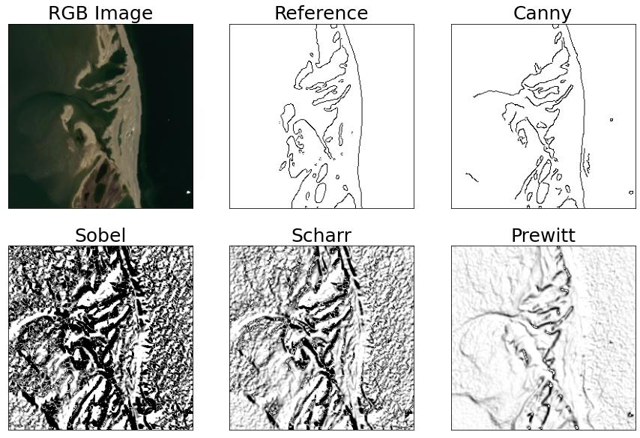
- Edges generally contain less distinctive information for feature matching.

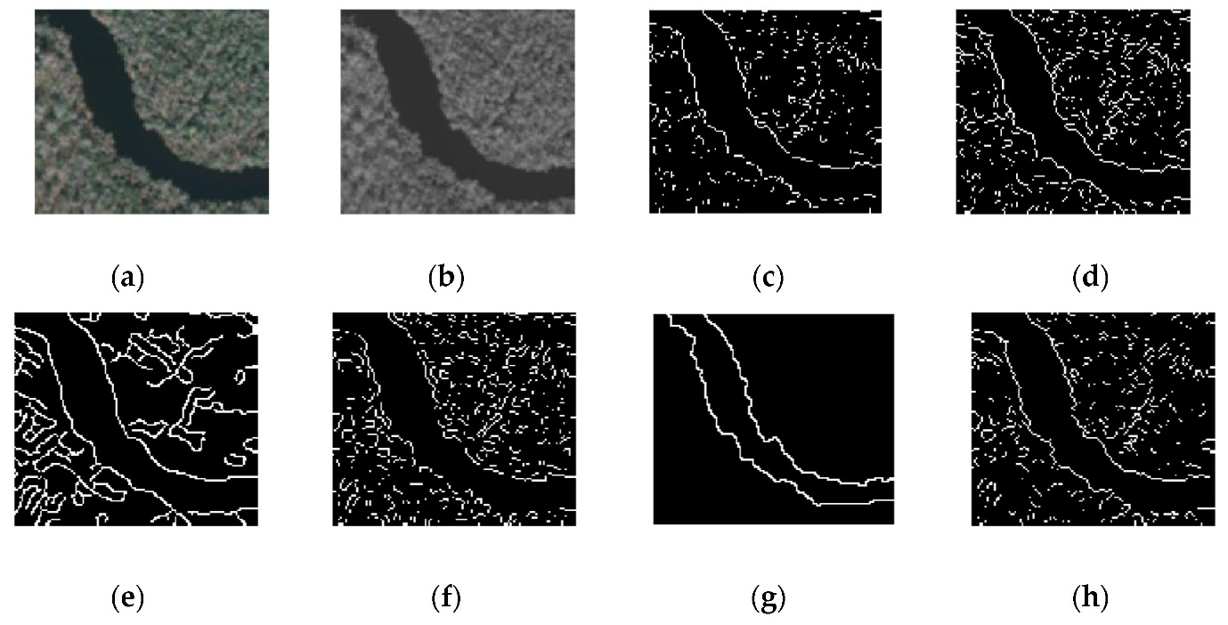
Harris Corner Detection
Harris Corner Detection is a feature detection technique used to identify corner points in an image.
A corner is a point where image intensity changes significantly in two directions. These points are more distinctive than points located only along a straight edge.
Examples of useful corners in satellite images:
- Building corners
- Road intersections
- Roof corners
- Field boundaries
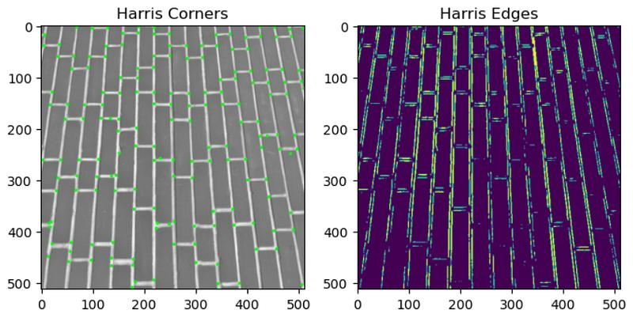
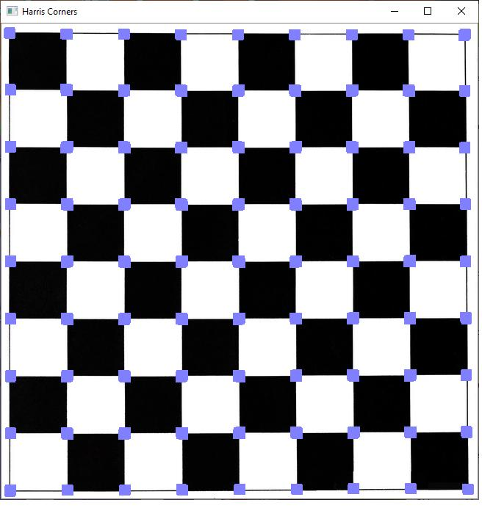

Harris Corner Detection in Satellite Images
Harris detection can identify distinctive points on structures such as buildings, roads and other geographical features.
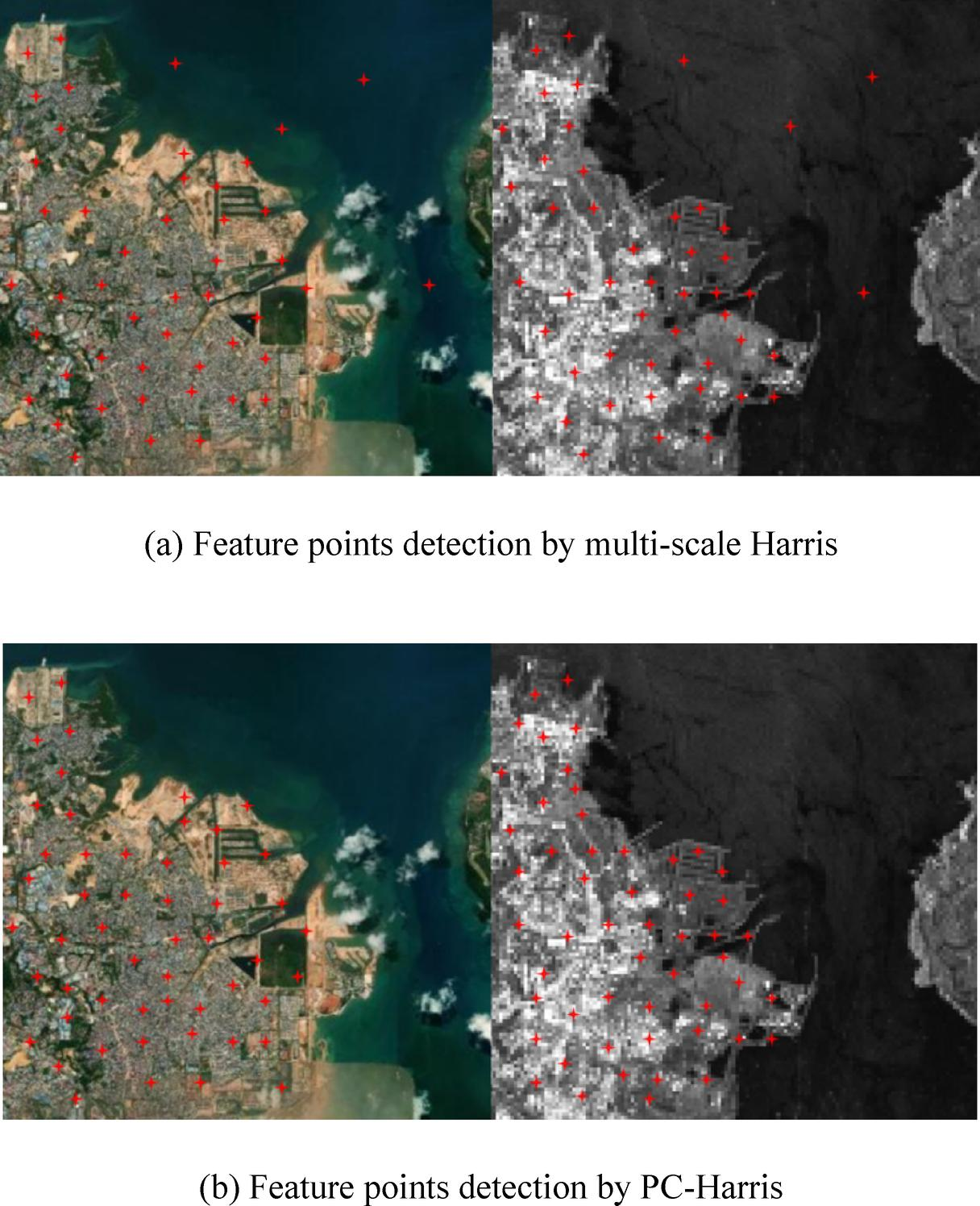
These points provide useful locations for comparing two satellite images.

Flowchart

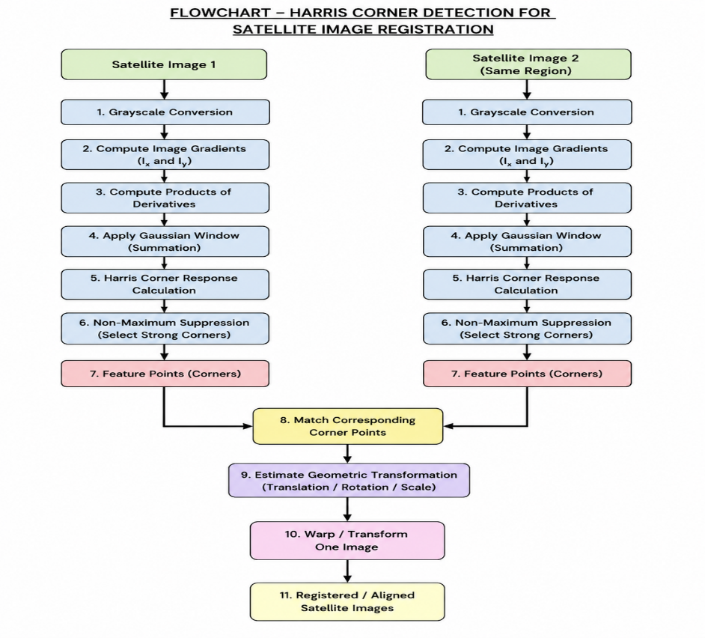

Feature Point Matching
After detecting corners in both satellite images, corresponding points are matched.
For example, the same building corner or road intersection appearing in both images can be treated as a corresponding feature point.
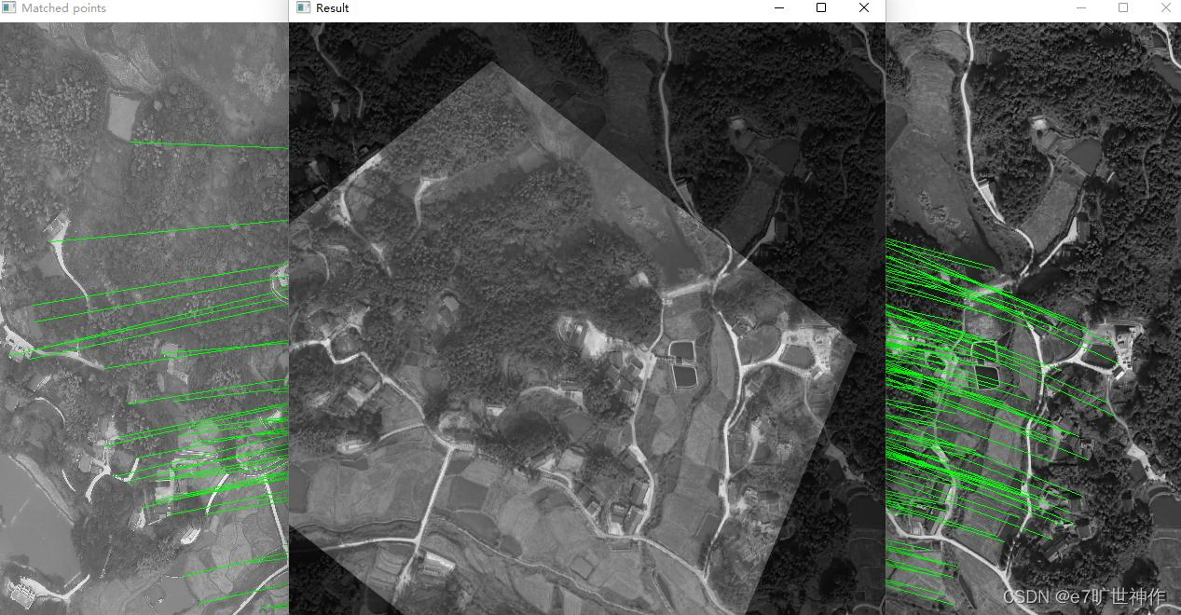

Geometric Transformation
Once corresponding corner points are obtained, the system estimates the transformation between the two images.
Possible transformations include:
- Translation
- Rotation
- Scaling
- Affine transformation
- Projective transformation
- Satellite Image Registration

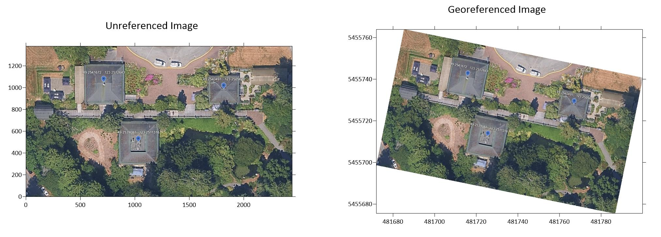

Satellite Image Registration
The matched Harris corner points are used to align the two satellite images. After transformation, corresponding geographical regions overlap more accurately.
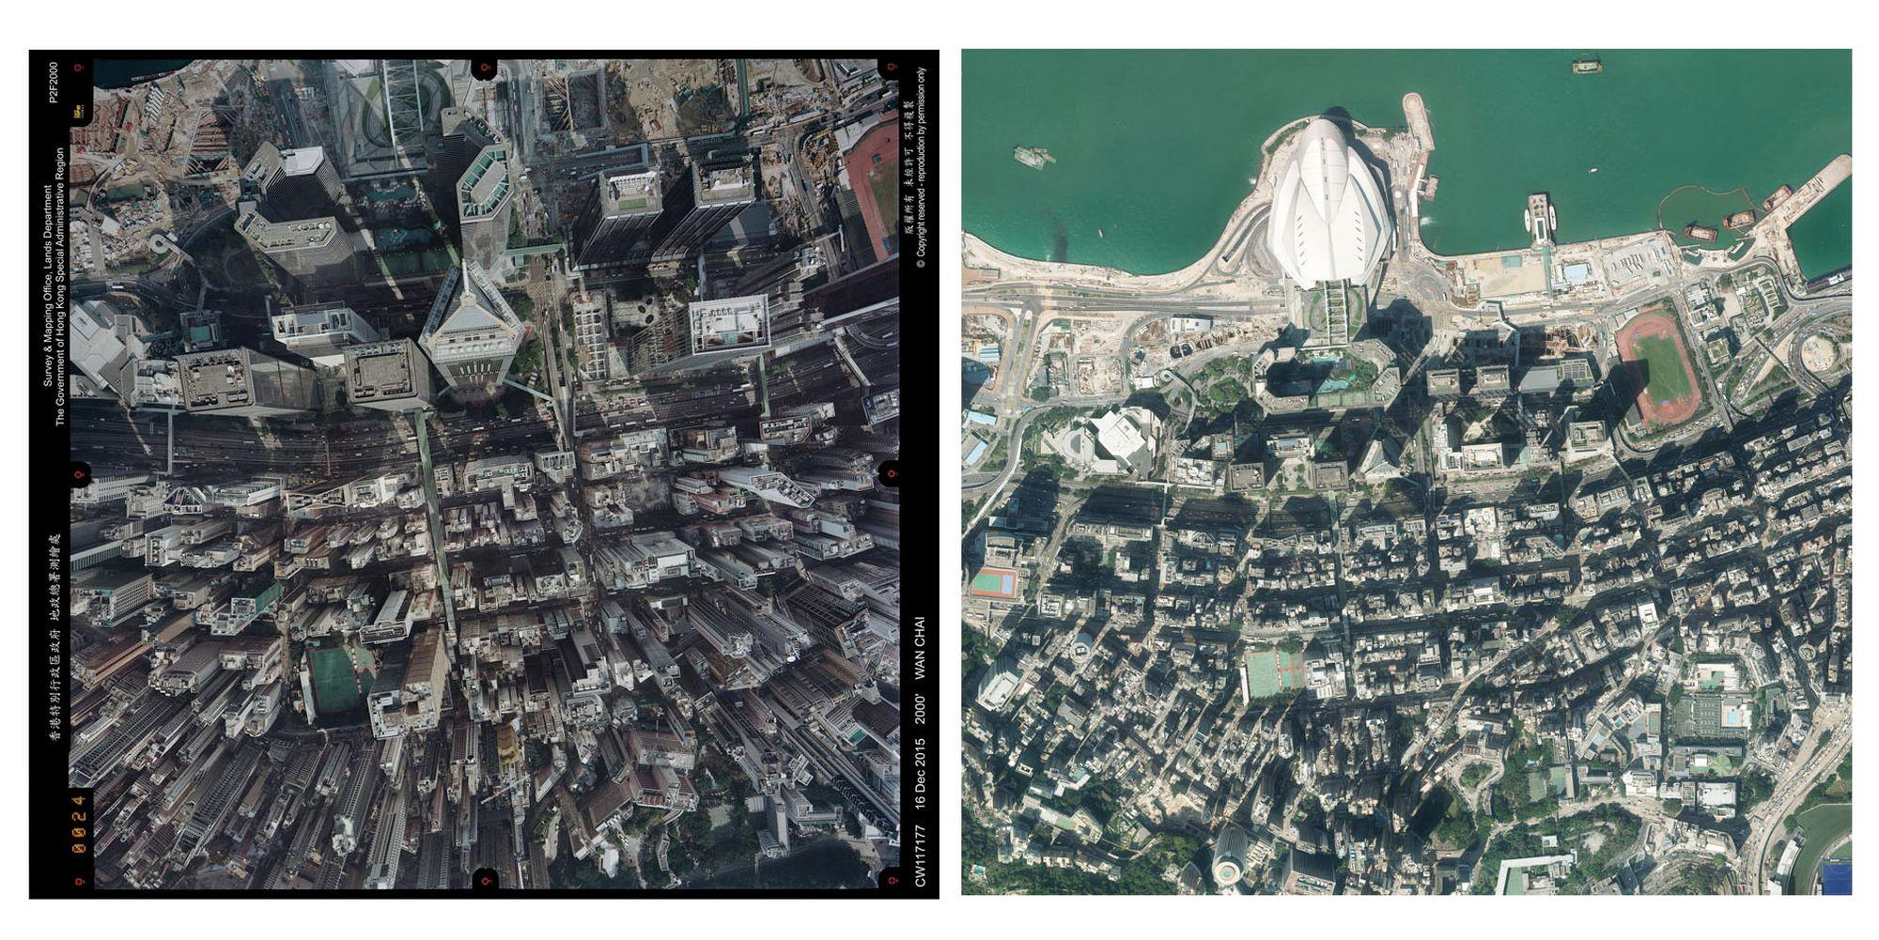

Question 2 – Image Representation for Real-Time Object Detection
Introduction
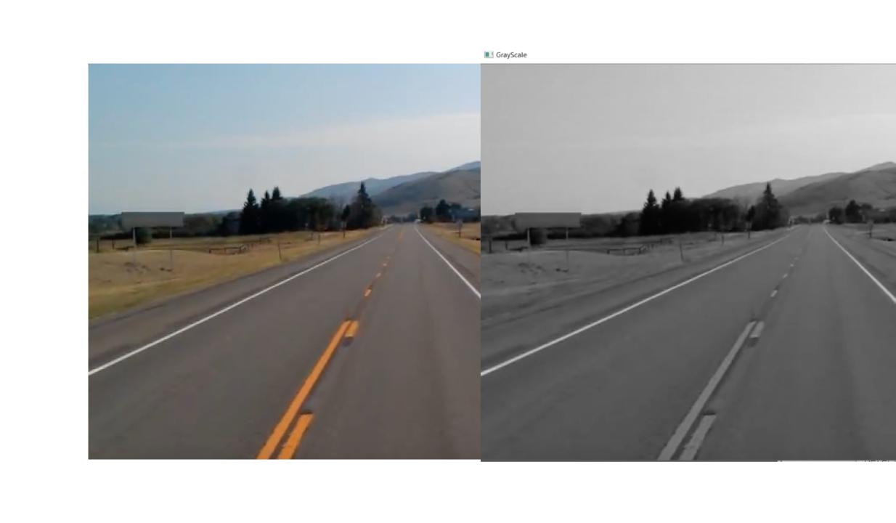
An autonomous surveillance system captures high-resolution colour images to detect vehicles and pedestrians in real time. Processing RGB images directly requires more memory and computational power. Therefore, RGB, grayscale, and binary representations can be compared to select the most suitable representation.
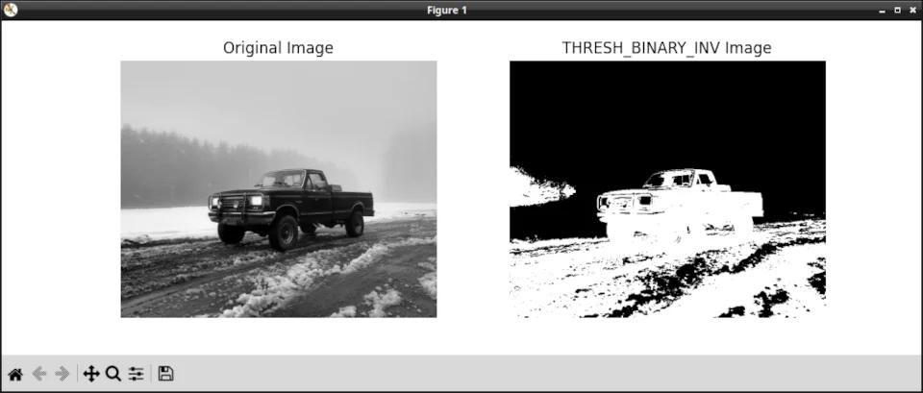
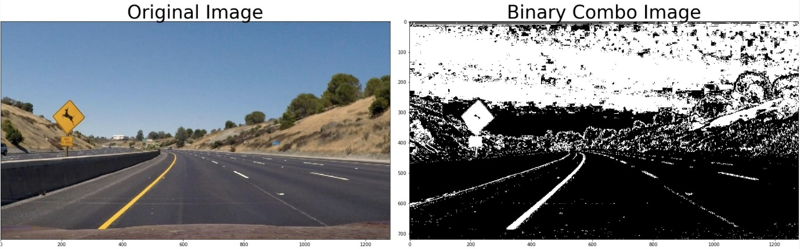

RGB Image
RGB images contain three channels: Red, Green and Blue.
Advantages
- Preserves complete colour information.
- Provides detailed image information.
Limitations
- Requires more memory.
Grayscale Image
A grayscale image contains only one intensity channel, usually with values from 0 to 255.
Advantages
- Requires less memory.
- Faster processing.
- Suitable for edge detection.
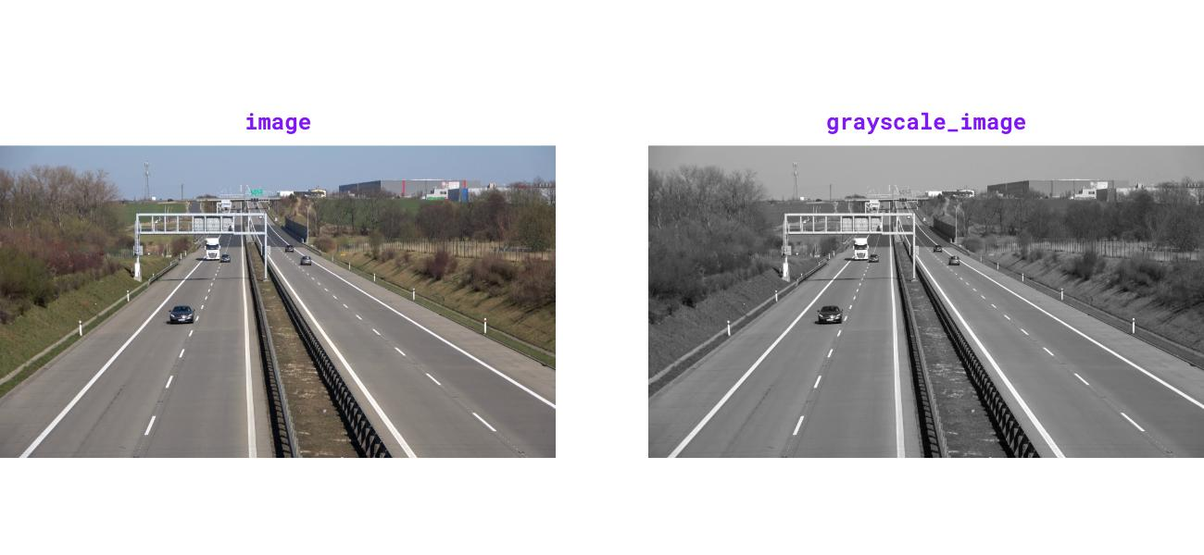
Binary Image
A binary image contains only two values:
0 → Black
255 → White
It is generally produced using thresholding.
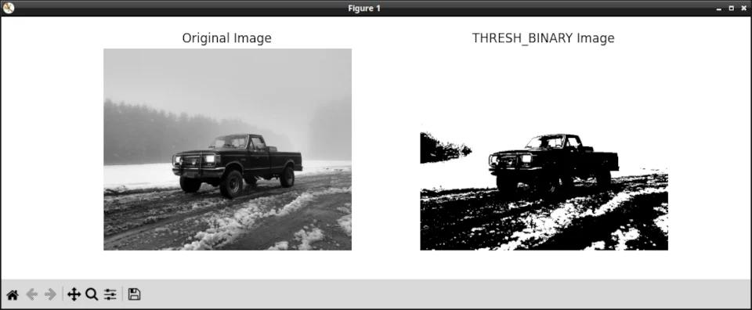

Effect on Edge and Feature Detection
RGB: Provides detailed information but requires more computation.
Grayscale: Preserves important intensity changes and is suitable for Sobel, Canny, Harris and SIFT.
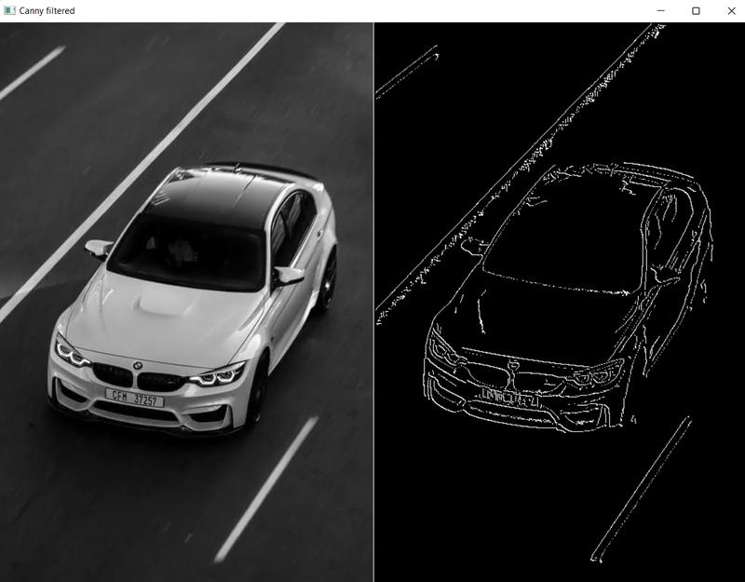
Binary: Provides clear boundaries but may lose fine image details.

Most Appropriate Representation
Grayscale is the most appropriate representation for this application when colour information is not essential.
It provides a good balance between accuracy and computational efficiency. It reduces memory usage and processing time while retaining the intensity information required for effective edge and feature detection.

